COFFEE RUST DISEASE IDENTIFICATION USING DECISION TREE ALGORITHMS
Santiago Hidalgo Ocampo  Universidad Eafit  Colombia  shidalgoo1@eafit.edu.co | Ana Sofía Gutiérrez  Universidad Eafit  Colombia  asgutierrt@eafit.edu.co | Mauricio Toro  Universidad Eafit  Colombia  mtorobe@eafit.edu.co

ABSTRACT

Coffee rust is an old disease that affects coffee crops, specifically the Coffea Arabic which happens to be the main variety of agricultural exports in Colombia. The objective of this paper is to propose a way to do an early identification of it through the use of decision trees in processing data of physicochemical variables in certain crops that are related to the apparition of the disease.

1.INTRODUCTION
In Colombia, coffee is one of the main agricultural exports; with an approximate production of 13.5M bags per year around 563,000 families depend on it. Several problems arise in the production process, including the rust plague, which is the main phytosanitary problem that affects coffee. Long known in coffee-growing areas of Africa, the Near East, India, Asia, and Australasia, coffee rust was only discovered in 1970 to be widespread in Brazil, the first known infected area in the Western Hemisphere. Ever since this outbreak of the disease, many countries have tried to eradicate the fungus that causes this by applying fungicide sprays and moving the crops to higher areas in which the low temperatures prevent the fungus to grow easily, but this is not a permanent solution.[4]

2. PROBLEM
Coffee rust’s diagnosis is usually not made on time which leads to a lack of control of the disease, and inevitably to high production losses. There are several varieties of coffee that are more resistant to rust, however, export coffee (Caturro coffee or Coffea Arabic) is one of the most susceptible varieties to suffer from this pest.

In view of this problem, constantly monitoring of the crops to detect the pest in time trough spectral reflectance, wireless sensor networks and water stress levels but this alone is not enough, all the collected data must be processed in order to detect the disease.

In this order of ideas, Eafit University developed a greenhouse capable of monitoring multiple physicochemical variables that are associated with the appearance of rust from a wireless sensor network, therefore, the objective of this project is to take advantage of the data that offers this system, to detect coffee rust from algorithms based on decision trees.

3. RELATED WORK

3.1 Chi-squared Automatic Interaction Detection

The CHAID algorithm, created by Kass (1980) and adapted by Magidson (1994), allows working with a categorical dependent variable (nominal or ordinal) from independent variables to establish an association or profile. [5]

It is a kind of multiple regression for categorical, discrete and discontinuous variables such as sex, socioeconomic status, religion, occupation, race, city, municipality, area, etc. in which there is a dependent variable (DV) and at least one independent variable (IV) and predicting the DV through the IV’s.
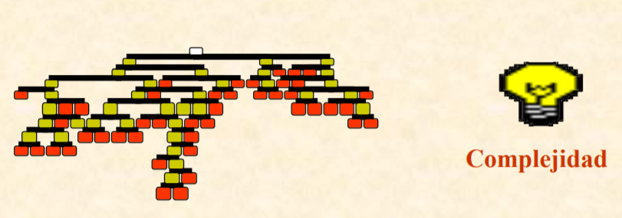
The CHAID divides the population into two or more distinct groups based on categories of the “best” predictor of a dependent variable. Then divide each of these into smaller groups based on variables from other predictors. This process of continuous division ends until no more statistically significant predictors are found (or until some unemployment rule is met) and CHAID displays the final subgroups or “segments” in an easy to understand tree diagram. [2]

Image obtained from Data mining with decision trees: https://web.fdi.ucm.es/posgrado/conferencias/JorgeMartin-slides.pdf

3.2 Classification and Regression Trees
The CART algorithm allows to classify an specific population or define profiles under established variables of any type. It comes from the field of Statistics and was developed by mathematicians from the University of Berkeley and Stanford (Breiman, Friedman, Olshen and Stone) in the mid-80s. [1]
The process can be schematized in 4 phases: building of the tree, stopping of the tree growth process (a maximum tree is constituted in a way that over-adjusts the information contained in our database), pruning of the tree or doing it simpler and leaving only the most important nodes and, finally, selection of the optimal tree with generalization capability. [7]

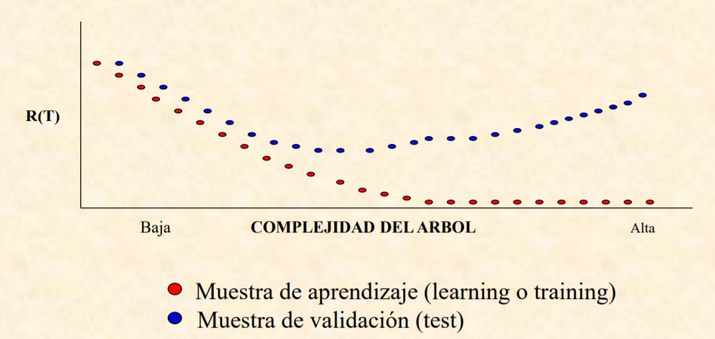
Image obtained from Data mining with decision trees: https://web.fdi.ucm.es/posgrado/conferencias/JorgeMartin-slides.pdf

3.3 ID3 (Iterative Dichotomiser 3) by Ross Quinlan
The main task of ID3 is constructing a decision tree. Nodes of the tree are labeled by attributes while arches are labeled by values of an attribute. Our assumption is that the set of examples is partitioned into at least two concepts. The attribute that is a label of the root is selected based on the maximum of information gain criterion, which means, the attribute that leads to more labeled cases of them all. The process continues until all members of the same branch belong to the same label, at this point, the tree does not need to be further partitioned.[3]
This algorithm is use in the location of branchpoints in pre-mRNA introns to provide insight into the early steps of splicing of it. A decision tree optimized by the ID3 algorithm finds the most concise and effective hierarchy of decisions to explain the process of branch-point selection by identifying the most important characteristics that determines it, being this a similar case to the one object of this study.[6]
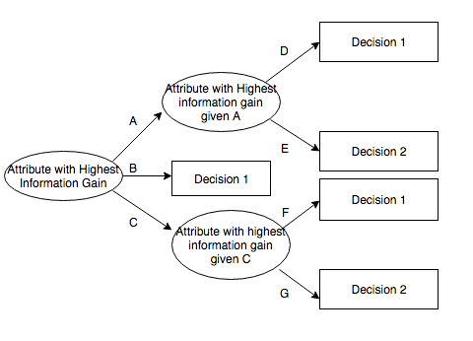
Image obtained from Potential ID3-generated decision tree. https://bit.ly/31ulBF1

3.4 C4.5 statistical classifier
Systems that construct classifiers are one of the commonly used tools in data mining. Such systems take as input a collection of cases, each described by its values of attributes, and output a classifier that can accurately predict the class to which a new case belongs.
C4.5 first grows an initial tree using the divide-and-conquer algorithm depending on whether all the cases belong to the same class or there is a more prominent case. Otherwise, it chooses a single attribute with two or more outcomes and makes this the root of the tree with one branch for each class and apply the same procedure recursively to each subset. Each path from the root of the tree to a leaf becomes a prototype rule whose conditions are the outcomes along the path and whose class is the label of the leaf. [8]
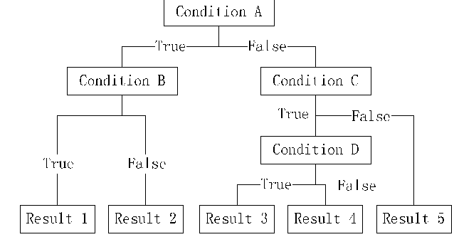
Image obtained from A Feature Selection Algorithm for C4.5: https://www.semanticscholar.org

REFERENCIAS

- Arevalillo, J.M. Data mining con árboles de decisión. Retrieved from Universidad Nacional Educación a Distancia, Madrid: https://bit.ly/2M9ZL61
- Bello, P., León, D. Técnica del Árbol CHAID. 2013. retrieved from: https://bit.ly/2Kt0e0X
- Jerzy, W. Selected Algorithms of Machine Learning from Examples. Fundamenta Informaticae 18 (1993), 193–207. Retrieved from Department of Computer Science, University of Kansas: https://bit.ly/2TtEuoH
- Petruzzello, M. Coffee rust: disease, 2017. Retrieved from Encyclopaedia Britannica: https://bit.ly/2GVrsvd
- Sanz, E., Ponce de León, Ana. Claves en la aplicación del algoritmo CHAID. un estudio del ocio físico deportivo universitario, 2010. Psicología del Deporte. 19 (2). 319-333. Retrieved from Universitat de les Illes Balears: https://bit.ly/2yUOopO
- Taggart, A., DeSimone, A.M., Shih, J.S., Filloux, M.E., Fairbrother, W. Nat Struct Mol Biol. US National Library of Medicine, 2012. 19(7). 719–721. Doi: 10.1038/nsmb.2327
- Trujillano, J., Sarria, A., Esquerda, A., Badia, M., Palma, M., March, J. Approach to the methodology of classification and regression trees, 2008. Retrieved from: https://bit.ly/2H2zu5z
- Xindong, W. et al. Top 10 algorithms in data mining. Know Inf Syst, 2008. 14. 1–37. Doi: 10.1007/s10115-007-0114-2

